AI-BASED FINANCIAL IDENTIFICATION BASED ON DEMOGRAPHY AND FINANCIAL FORECASTING
Scope and Limitations
Product: FinSight AI
Department of Computer Science and Engineering, TKR College of Engineering and Technology (Autonomous)
Batch C9 (CSE-C) · Academic year [ACADEMIC YEAR]
Table 1: Project team
S.No. | Student name | Roll number
1 | MOHD AHMED | 23K91A05F7
2 | MANNE UPENDER | 23K91A05E6
3 | PADALA RAJESH | 23K91A05H7
4 | MADAGOUNI HARSHAVARDHAN GOUD | 23K91A05D5

Project guide: B SRIKANTH
Chapter and section numbers quoted in the text (for example Section 6.6 or Chapter 8) refer to the full project report, 17.Final Document. Figures and tables in this document are numbered from 1.

1. SCOPE
The scope was fixed by the project abstract (identify financial profiles from demographic attributes and forecast economic trends through a web application) and then narrowed to what the available data support.

In scope
• Classification of one individual's demographic and financial profile (12 inputs) into an Emerging, Developing or Established profile with a Low, Moderate or High risk band and a financial-strength score.
• The preprocessing and feature-engineering chain in scripts/feature_engineering.py, applied identically at training and prediction time through a scikit-learn Pipeline.
• Four candidate classifiers (Logistic Regression, Random Forest, Gradient Boosting, XGBoost) evaluated by stratified 80/20 split and 5-fold cross-validation, with the best selected by ROC-AUC.
• SHAP explainability: global importance charts at training time and live local contributions for every assessment, with plain-language sentences.
• A 12-month Holt-Winters forecast of an economic index with a 95% band, and a what-if comparison of a baseline and a changed scenario.
• A Flask JSON API (port 8409), the original server-rendered pages, a React front end (port 5409) with a sample login, a dashboard, performance views and a responsive light / dark interface.
• A reproducible training pipeline, an automated test suite (pytest), a smoke test and the documentation set.

Out of scope
• Credit decisions. The model predicts an income band from census-style attributes; it is not a credit score, a default or distress predictor, or a lending recommendation.
• Forecasting an individual's future finances. The forecast is of an aggregate economic index and is trained on a synthetic series.
• Real macroeconomic indicators (inflation, benchmark lending rates, GDP) named in the project abstract; they are not integrated.
• Transaction-level or bank data, income verification, identity checks and any personal-data storage.
• User accounts, real authentication, role management, audit logging and a relational database (the sample login is a browser-only demo gate).
• Fairness mitigation, causal inference, entity-grouped or temporal validation, and external validation on current data.
• Cloud deployment and horizontal scaling; the Docker files cover the original Flask pages only.
Table 2: Scope at a glance
Area | Covered | Not covered
Data | UCI Adult / Census Income (public), synthetic monthly index | Account-level transaction records, real macro series, personal data storage
Models | Four supervised classifiers, Holt-Winters smoothing | Deep learning, causal models, individual-level forecasting
Explanation | Global and live local SHAP, what-if simulation | Counterfactual recourse, fairness mitigation
Product | Flask API, React interface, sample login, tests | Real authentication, database, cloud deployment

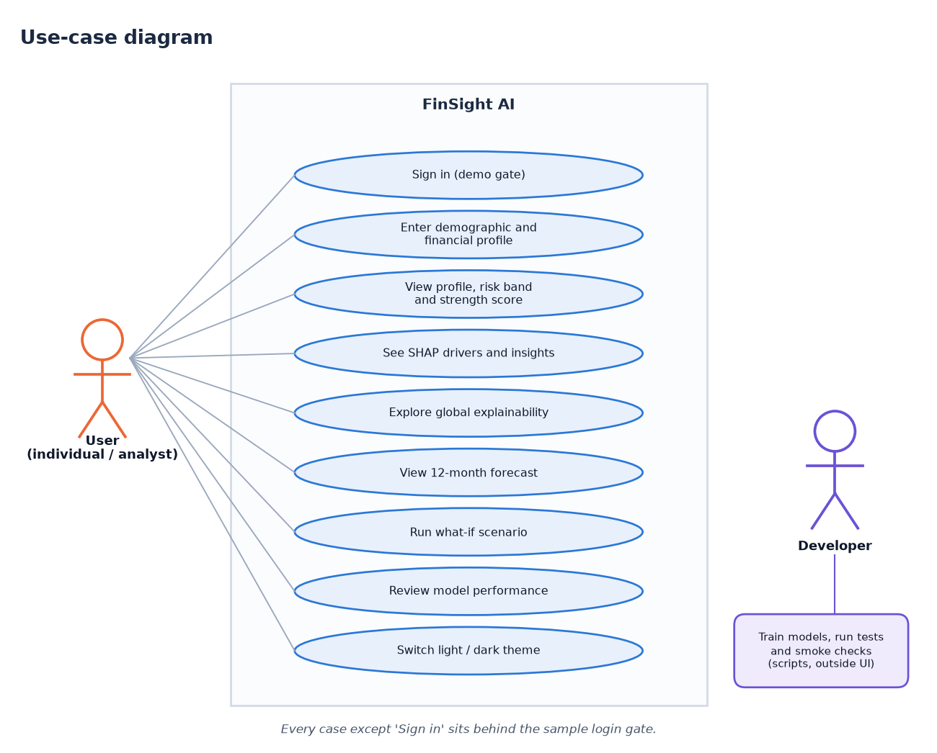
Figure 1: What the user can do within the scope of the system (use-case diagram)

2. ASSUMPTIONS
The results hold under the following assumptions; where one is weakened, the corresponding numbers should be re-measured.
• The 1994 US census extract (UCI Adult) is a usable stand-in for demographic and financial profiles; its income label is taken as ground truth.
• One row describes one person, so a random stratified split does not leak entities between training and test sets.
• Users enter values from the permitted option lists and ranges (age 16-100, hours 1-99, gains and losses 0-1,000,000).
• The census sampling weight fnlwgt has no meaning for a new user and is imputed with the training median at prediction time.
• The Household Financial Conditions Index used for forecasting is illustrative; its trend and seasonality are assumed to continue unchanged over the 12-month horizon.
• The system runs on a single local machine with Python 3.11 or newer and Node.js 18 or newer.

3. LIMITATIONS
The limitations below are stated plainly because they change how the results may be used. Each is followed by its practical consequence.
Old, US-specific data. The Adult extract describes 1994 US adults. Its income distribution, occupations and wage levels do not describe current populations, and the countries in the form map to a handful of census categories.
Consequence: absolute income levels, occupations and the country list are dated and US-centric, so scores for a present-day user are an analogy to 1994 patterns.
Income is not creditworthiness. The target is income above 50K. The report therefore claims a financial-profile signal only; it makes no claim about repayment behaviour or distress.
Consequence: nothing in this report supports lending, scoring or distress claims; the profile names (Emerging, Developing, Established) describe income-band membership only.
Synthetic forecast series. The forecast component is validated only against its own generator (back-test MAPE below 1%), which says nothing about accuracy on real economic data.
Consequence: the back-test (MAE 1.429 against 4.504 for repeating the last value) shows the method recovers the pattern it was generated with; it is not evidence about real economies.
Sensitive attributes in the model. Sex, race and marital status are inputs and marital status is the most important SHAP feature. No fairness audit or mitigation was performed, so the model may reproduce historical bias.
Consequence: the model may encode historical bias, for example through the sex and marital-status effects visible in the SHAP ranking. Group metrics and mitigation are future work.
Recall of the positive class is modest. At the default 0.5 threshold the selected model finds about two thirds of the people with income above 50K; the threshold analysis shows how this trades against precision.
Consequence: at 0.5 the model misses 780 of the 2,338 positive test records; lowering the threshold to 0.35 raises recall to 78.1% at the price of precision 69.0%.
Model selected on the test split. The best model was chosen by test ROC-AUC, with no separate validation set, no hyperparameter search and no significance test; the cross-validation ranking agrees with the test ranking.
Consequence: reported test scores are slightly optimistic for the selected model; the cross-validation ranking (XGBoost first) agrees, but differences between models were not tested for significance.
Extrapolation in what-if scenarios. Large changes (for example investment gains of 80,000) move the score by close to 100 points because the training data are sparse there; scenario output is a model simulation, not a causal prediction.
Consequence: users should read the what-if comparison as a statement about the model, not about what would happen if they changed their circumstances.
Demo-grade security and storage. The login is client-side only, no data is persisted, the session secret has a development default, and the Docker image serves the Flask pages only.
Consequence: the application must not be exposed beyond a local machine or used with real personal data until real authentication, secret management and storage are added.
Not financial advice. Outputs are informational and must not be used as the sole basis for any financial decision.
Consequence: every screen repeats a disclaimer; the system supports exploration and education, not decisions.

4. WHAT WAS NOT MEASURED
Several things a complete evaluation would include were not measured. They are listed so that no reader mistakes their absence for a good result.
Table 3: Items not measured
Item | Status | Why
External validation on current or non-US data | Not done | No second dataset with the same schema was available
Fairness audit (group error rates, equalised odds) | Not done | Sex, race and marital status are inputs; mitigation is future work [39], [40]
Forecast accuracy on real economic data | Not done | Only the synthetic series exists; the back-test (MAPE 1.00%) is against its own generator
Significance of differences between models | Not done | No DeLong or paired test was run [30]
Hyperparameter search | Not done | Fixed settings were used; no tuned variant was compared
Entity-grouped or temporal validation | Not applicable | One row per person and no time dimension in the classification data
Calibration beyond ten bins; recalibration | Partly | Ten-bin reliability table and Brier score 0.086 only; no calibration method applied [37], [38]
Load and concurrency testing | Not done | Single-user latency only (68.9 ms median)
User-acceptance study, accessibility audit, browser matrix | Not done | No participants; checked only in the browser used for the screenshots
Security testing | Not done | The sample login is a demo gate and was not audited

